Factor Analysis

Notes
Output Created |  | 28-JUN-2021 14:02:12
Comments
Input | Data | /Users/coderlax/Desktop/EO Hackathon/Asia/Quality of Life/COVID/Zscore/Z2.sav
Input | Active Dataset | DataSet7
Input | Filter | <none>
Input | Weight | <none>
Input | Split File | <none>
Input | N of Rows in Working Data File | 86
Missing Value Handling | Definition of Missing | MISSING=EXCLUDE: User-defined missing values are treated as missing.
Missing Value Handling | Cases Used | LISTWISE: Statistics are based on cases with no missing values for any variable used.
Syntax |  | FACTOR  /VARIABLES ZGrcoerypos ZTransitPos ZResipos  /MISSING LISTWISE  /ANALYSIS ZGrcoerypos ZTransitPos ZResipos  /PRINT UNIVARIATE INITIAL CORRELATION KMO EXTRACTION ROTATION  /FORMAT SORT  /PLOT EIGEN  /CRITERIA FACTORS(3) ITERATE(25)  /EXTRACTION PC  /CRITERIA ITERATE(25)  /ROTATION VARIMAX  /METHOD=COVARIANCE.
Resources | Processor Time | 00:00:00.15
Resources | Elapsed Time | 00:00:01.00
Resources | Maximum Memory Required | 1984 (1.938K) bytes

Descriptive Statistics
 | Mean | Std. Deviation | Analysis N
ZGrcoerypos | 3.8896300 | 1.00000099 | 86
ZTransitPos | 3.0598509 | .99999997 | 86
ZResipos | 1.2636603 | .99999998 | 86

Correlation Matrix
 |  | ZGrcoerypos | ZTransitPos | ZResipos
Correlation | ZGrcoerypos | 1.000 | .269 | -.176
Correlation | ZTransitPos | .269 | 1.000 | -.776
Correlation | ZResipos | -.176 | -.776 | 1.000

KMO and Bartlett's Testª
Kaiser-Meyer-Olkin Measure of Sampling Adequacy. |  | .525
Bartlett's Test of Sphericity | Approx. Chi-Square | 83.233
Bartlett's Test of Sphericity | df | 3
Bartlett's Test of Sphericity | Sig. | <.001

a. Based on correlations

Communalities
 | Raw |  | Rescaled
 | Initial | Extraction | Initial | Extraction
ZGrcoerypos | 1.000 | 1.000 | 1.000 | 1.000
ZTransitPos | 1.000 | 1.000 | 1.000 | 1.000
ZResipos | 1.000 | 1.000 | 1.000 | 1.000

Extraction Method: Principal Component Analysis.

Total Variance Explained
 | Component | Initial Eigenvaluesª |  |  | Extraction Sums of Squared Loadings
 | Component | Total | % of Variance | Cumulative % | Total | % of Variance | Cumulative %
Raw | 1 | 1.888 | 62.942 | 62.942 | 1.888 | 62.942 | 62.942
Raw | 2 | .894 | 29.799 | 92.741 | .894 | 29.799 | 92.741
Raw | 3 | .218 | 7.259 | 100.000 | .218 | 7.259 | 100.000
Rescaled | 1 | 1.888 | 62.942 | 62.942 | 1.888 | 62.942 | 62.942
Rescaled | 2 | .894 | 29.799 | 92.741 | .894 | 29.799 | 92.741
Rescaled | 3 | .218 | 7.259 | 100.000 | .218 | 7.259 | 100.000

Total Variance Explained
 | Component | Rotation Sums of Squared Loadings
 | Component | Total | % of Variance | Cumulative %
Raw | 1 | 1.023 | 34.110 | 34.110
Raw | 2 | 1.009 | 33.647 | 67.758
Raw | 3 | .967 | 32.242 | 100.000
Rescaled | 1 | 1.023 | 34.110 | 34.110
Rescaled | 2 | 1.009 | 33.647 | 67.758
Rescaled | 3 | .967 | 32.242 | 100.000

Extraction Method: Principal Component Analysis.
a. When analyzing a covariance matrix, the initial eigenvalues are the same across the raw and rescaled solution.

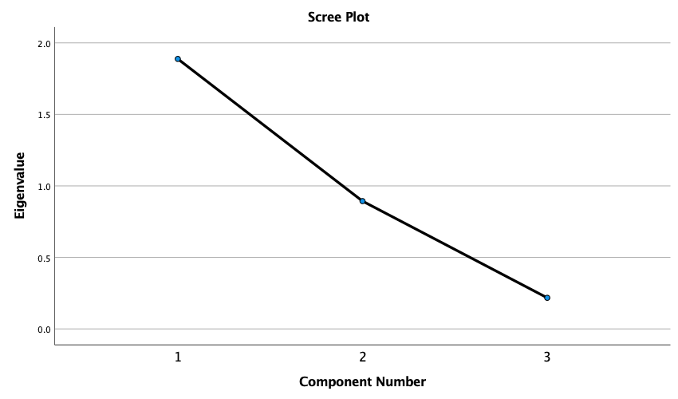

Component Matrixª
 | Raw |  |  | Rescaled
 | Component |  |  | Component
 | 1 | 2 | 3 | 1 | 2 | 3
ZTransitPos | .928 | -.162 | .335 | .928 | -.162 | .335
ZResipos | -.903 | .285 | .322 | -.903 | .285 | .322
ZGrcoerypos | .460 | .887 | -.042 | .460 | .887 | -.042

Extraction Method: Principal Component Analysis.ª
a. 3 components extracted.

Rotated Component Matrixª
 | Raw |  |  | Rescaled
 | Component |  |  | Component
 | 1 | 2 | 3 | 1 | 2 | 3
ZResipos | .908 | -.072 | -.413 | .908 | -.072 | -.413
ZGrcoerypos | -.066 | .992 | .110 | -.066 | .992 | .110
ZTransitPos | -.441 | .144 | .886 | -.441 | .144 | .886

Extraction Method: Principal Component Analysis.
Rotation Method: Varimax with Kaiser Normalization.ª
a. Rotation converged in 4 iterations.

Component Transformation Matrix
Component | 1 | 2 | 3
1 | -.667 | .347 | .660
2 | .305 | .935 | -.184
3 | .680 | -.079 | .729

Extraction Method: Principal Component Analysis.
Rotation Method: Varimax with Kaiser Normalization.

